**Assignment 4**

**Linear search**

**Pseudocode:**

Int a [5]={3,4,5,6,7,8},key,n,flag=0;

For(int i=0;i<n;++){

If{

A[i]==key

flag=1;

}

If flag==1;

Printf(“key is found”)

Else {

Printf(“Not found”)

**Flowchart**

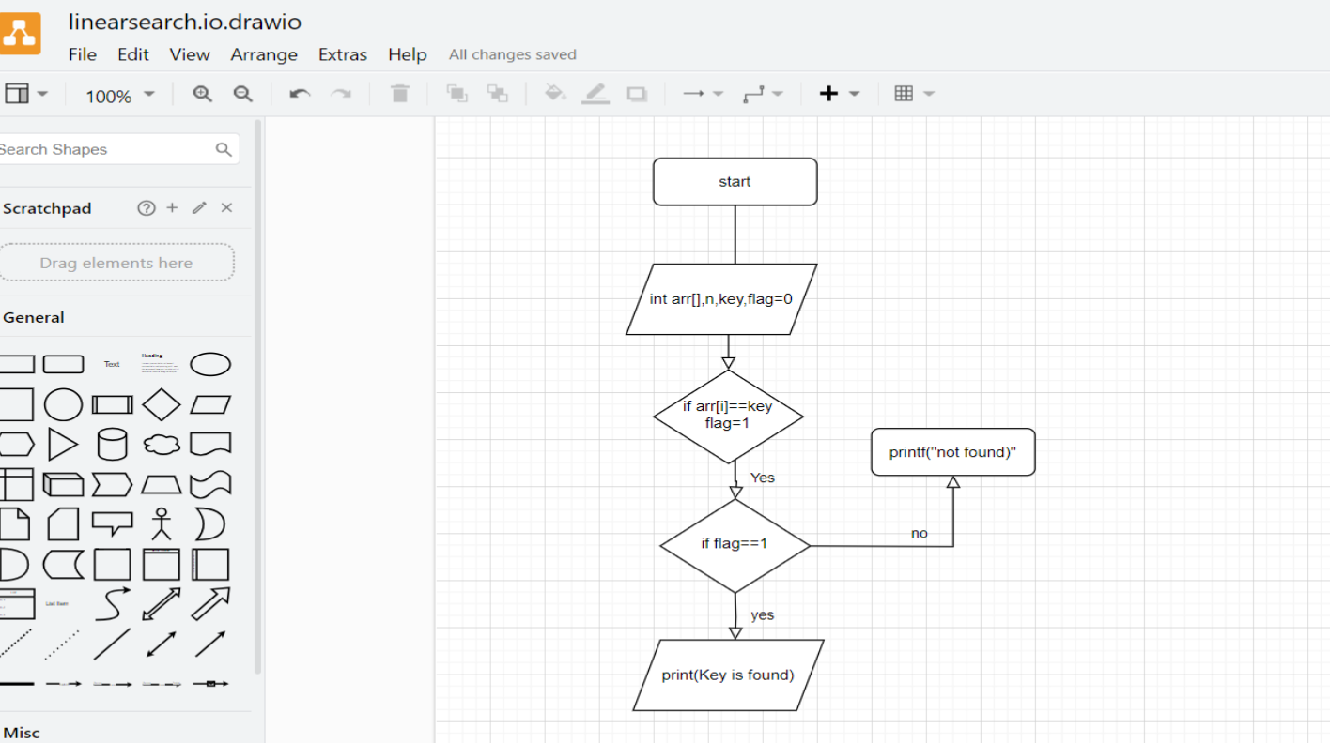

**Algorithm:**

1 Take arr,flag=0,key,n

2. we give the value of key to be found in array

3 then we use loop to traverse all the element in array if arr[i]==key we make flag=1

4. if flag==1 print key is found ,else print not found in the array